**National Textile University, Faisalabad**

**Department of Computer Science**

**Project Title:** “Water Quality Monitoring System”

**Submitted To:** Dr. Nasir Mahmood

**Subject:** Embedded IoT Systems

**Section:** BSCS-5th-B

**Date:** 4-Jan-2026

|  |  |
| --- | --- |
| **Name:** | **Registration no:** |
| Rizwana Bashir | 23-NTU-CS-1088 |
| Nimra Fatima | 23-NTU-CS-1081 |

**Group Members**

Table of Contents

Water Quality Monitoring System 3

Abstract 3

Introduction 3

Problem Statement 3

Objectives 4

Tools and Technologies Used 4

Hardware Components 4

Software Components 4

Programming Language 4

System Architecture 4

TDS-Based Threshold levels: 4

Block Diagram: 5

Working Methodology 6

Algorithm 6

Code Explanation 6

Flowchart: 7

Hardware Prototype of Water Quality Monitoring System 8

Circuit Diagram: 8

Working of project: 9

❖ Mineral water Quality Testing: 9

Blynk cloud Output data: 10

❖ Tap water Quality Testing: 10

Blynk cloud Output data: 11

❖ Salted water Quality Testing: 11

Blynk cloud Output data: 12

Results 12

Conclusion 12

Future Scope 13

# Water Quality Monitoring System

## Abstract

This project presents an IoT-based Water Quality Monitoring System designed to measure and monitor key water quality parameters in real time. The system uses an ESP32 microcontroller interfaced with a TDS sensor to determine the Total Dissolved Solids (TDS) level of water and calculate Electrical Conductivity (EC). The measured values are displayed locally on an OLED screen and transmitted wirelessly to the Blynk Cloud platform for remote monitoring through a mobile application. Visual indicators such as LEDs and an audible buzzer provide immediate alerts based on water quality conditions. The system offers a low-cost, efficient, and user-friendly solution for monitoring water quality in domestic and educational environments.

## Introduction

Clean and safe water is essential for human health and daily activities. Traditional water testing methods are often manual, time-consuming, and unsuitable for continuous monitoring. With the advancement of IoT technologies, real-time water quality monitoring has become more accessible and affordable. This project focuses on developing a smart water quality monitoring system that continuously measures water quality parameters and provides instant feedback both locally and remotely. By integrating sensors, a microcontroller, and cloud-based monitoring, the system enhances efficiency, accuracy, and ease of use.

## Problem Statement

Manual water quality testing does not provide real-time results and requires laboratory equipment and skilled personnel. There is a need for an automated system that can continuously monitor water quality parameters and alert users immediately when water becomes unsafe for use.

## Objectives

* To measure Total Dissolved Solids (TDS) in water using a TDS sensor.
* To calculate Electrical Conductivity (EC) from TDS values.
* To display water quality data on an OLED screen.
* To send real-time data to a mobile application using Blynk Cloud.
* To provide visual using three different LEDs and audible alerts using buzzer based on water quality levels.

## Tools and Technologies Used

### Hardware Components

* ESP32 Microcontroller
* TDS sensor
* OLED Display (128×64)
* LEDs (Green, Yellow, Red)
* Buzzer
* Connecting Wires

### Software Components

* Platformio
* Blynk Cloud Platform
* Blynk Mobile Application
* Vs code

### Programming Language

* C++

## System Architecture

The system architecture consists of a TDS sensor connected to the ESP32 microcontroller. ESP32 processes sensor data, displays the values on an OLED screen, and sends the data to Blynk Cloud using Wi-Fi. LEDs and a buzzer provide local alerts based on predefined thresholds.

## TDS-Based Threshold levels:

|  |  |  |  |
| --- | --- | --- | --- |
| Water Quality Status | TDS Range (ppm) | LED Indication | Buzzer Status |
| SAFE | TDS ≤ 300 ppm | Green LED ON | OFF |
| MODERATE | 300 ppm < TDS ≤ 500 ppm | Yellow LED ON | OFF |
| UNSAFE | TDS > 500 ppm | Red LED ON | ON |

## Block Diagram:

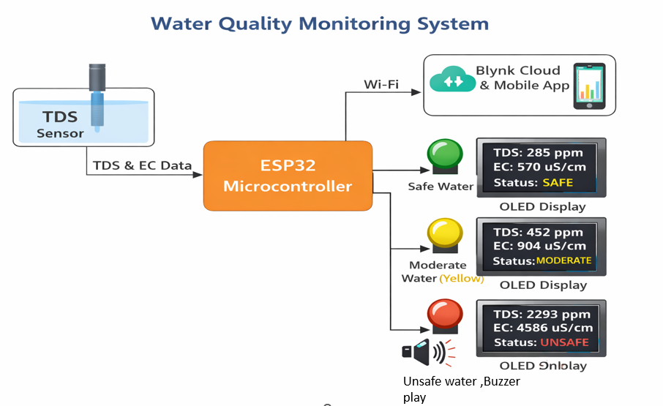

## Working Methodology

1. The TDS sensor measures the dissolved solids in water and provides an analog signal.
2. The ESP32 reads the analog signal through its ADC pin.
3. The analog value is converted into voltage and then into TDS (ppm).
4. Electrical Conductivity (EC) is calculated from the TDS value.
5. The processed data is displayed on the OLED screen.
6. LEDs and buzzer are activated based on water quality levels.
7. The ESP32 sends TDS, EC, and status values to the Blynk Cloud.
8. Users can monitor real-time data on the Blynk mobile application.

## Algorithm

1. Initialize ESP32, OLED display, Wi-Fi, and Blynk connection.
2. Read analog value from TDS sensor.
3. Convert analog value to voltage.
4. Calculate TDS and EC values.
5. Compare TDS value with predefined thresholds.
6. Activate corresponding LED and buzzer.
7. Display values and status on OLED.
8. Send data to Blynk virtual pins.
9. Repeat the process after a fixed interval.

## Code Explanation

The project code begins with defining Blynk template credentials and including required libraries for Wi-Fi, Blynk, OLED display, and ESP32 functionality. The ESP32 connects to a Wi-Fi network and initializes the OLED display. The TDS sensor is connected to analog pin 34, while LEDs and a buzzer are connected to digital pins.

The readAndDisplayAndSend() function reads the sensor value, converts it into voltage, and calculates TDS and EC values. Based on the TDS range, the system determines water quality status as SAFE, MODERATE, or UNSAFE. Corresponding LEDs are turned on, and the buzzer is activated for unsafe conditions. The data is displayed on the OLED screen and sent to the Blynk application using virtual pins.

## Flowchart:

# Hardware Prototype of Water Quality Monitoring System

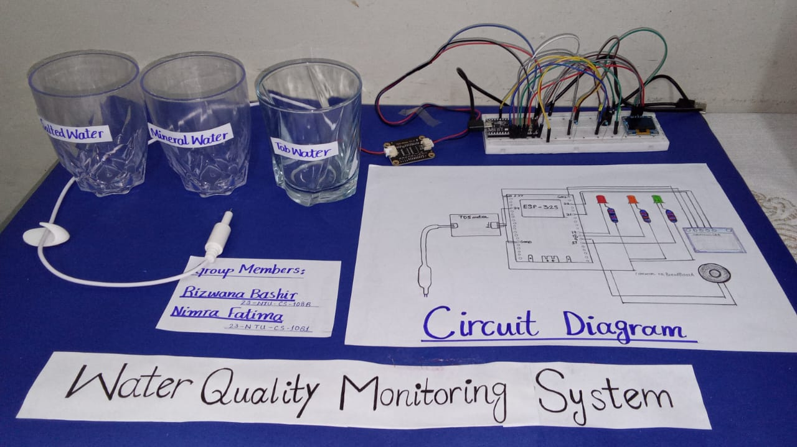

## Circuit Diagram:

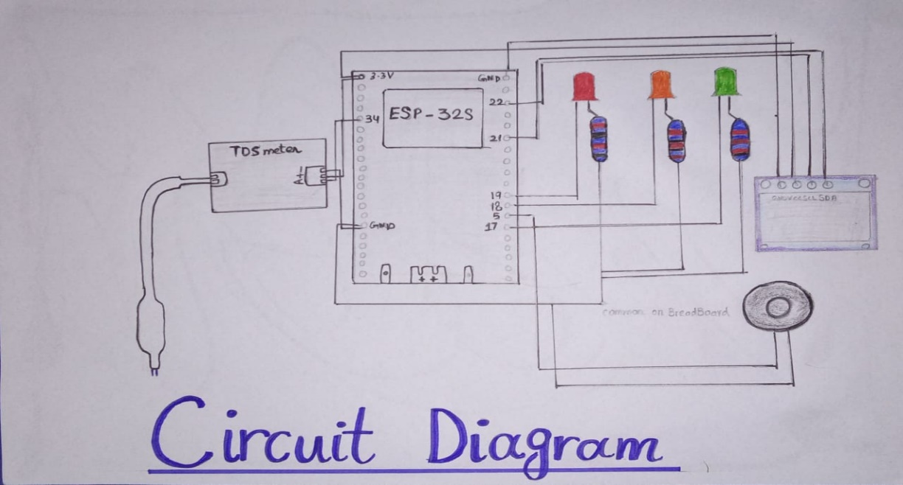

## Working of project:

For working here, we use three different categories of water:

1. Mineral water.
2. Normal tap water.
3. Salted water.

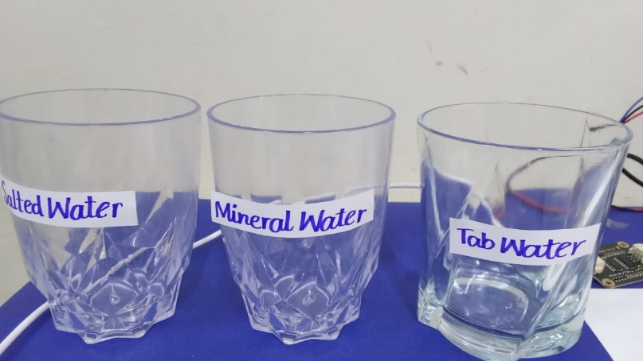

## Mineral water Quality Testing:

When mineral water was tested, the system recorded a **TDS value of 285.27 ppm** and an **EC value of 570.55 µS/cm**. Since the TDS value was within the safe range, the **green LED** was turned ON. The OLED display showed the status of the water as **“SAFE”**, indicating that the water quality is suitable for consumption.

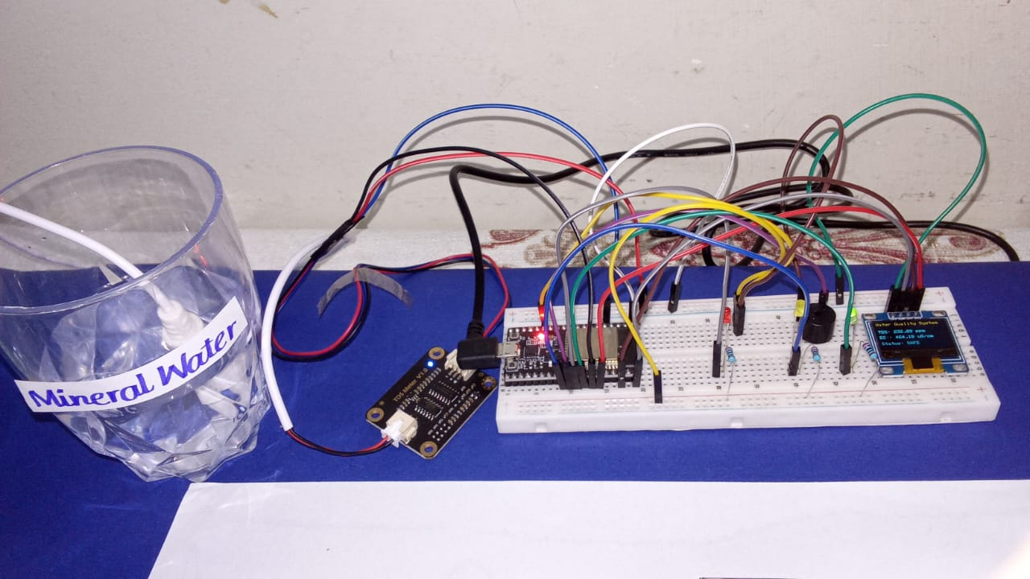

## Blynk cloud Output data:

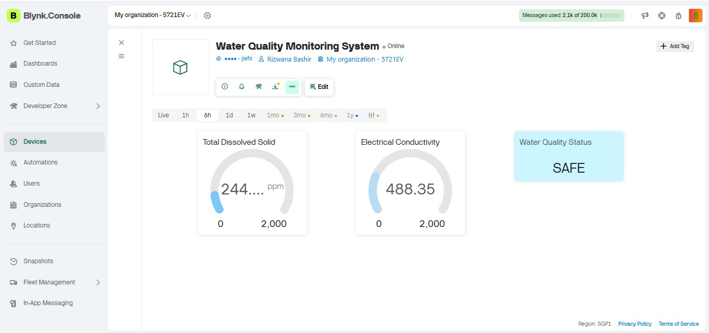

## Tap water Quality Testing:

In the case of normal tap water, the measured **TDS value was 452.09 ppm,** and the **EC value was 904.18 µS/cm**. These values fall within the moderate range. As a result, the **yellow LED** was activated while the green LED remained OFF. The OLED display indicated the water quality status as **“MODERATE”**, showing that the water is acceptable but not ideal for drinking without treatment.

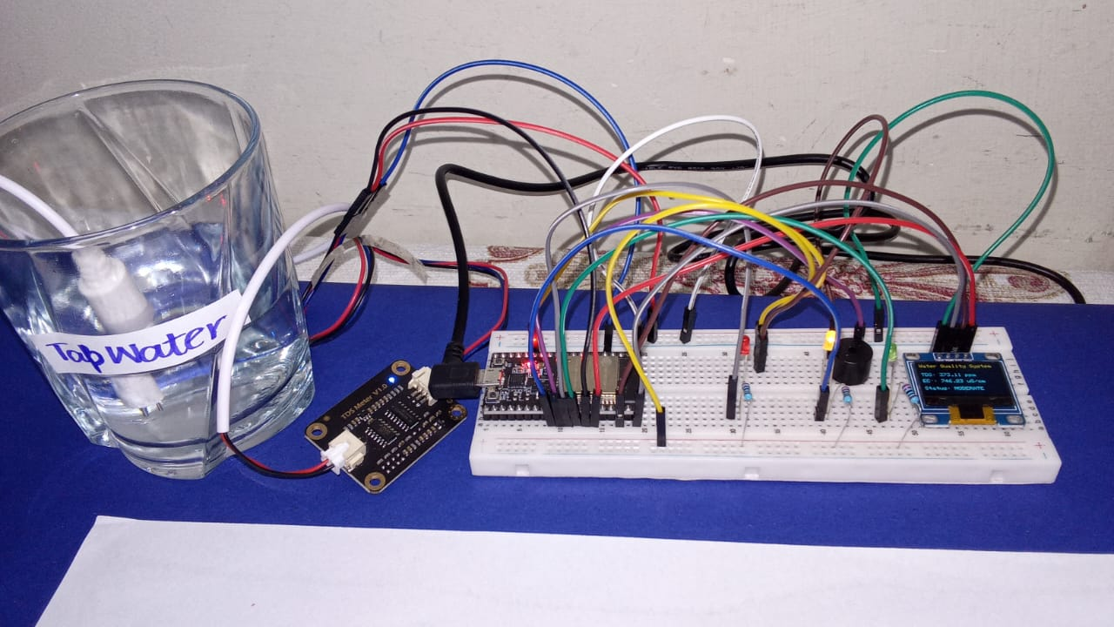

## Blynk cloud Output data:

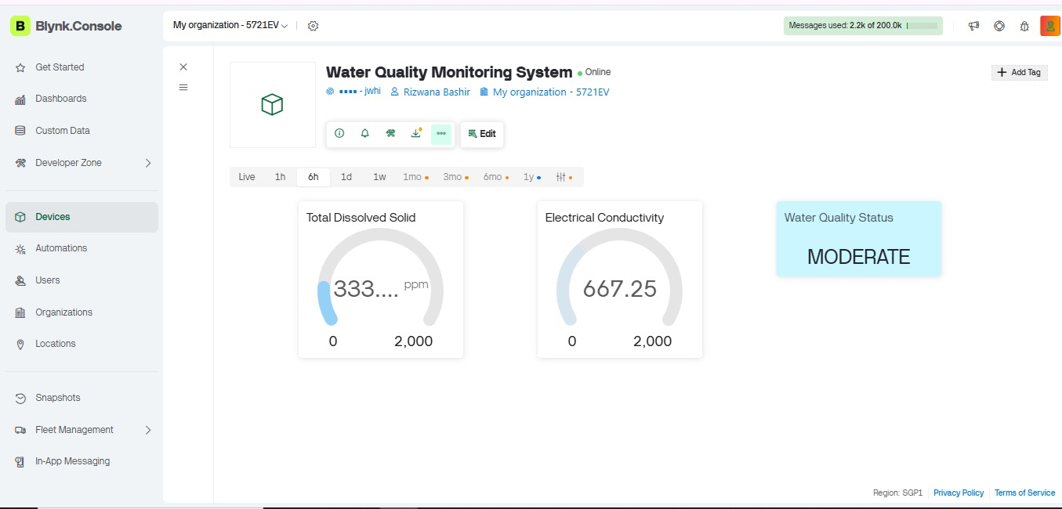

## Salted water Quality Testing:

For salted water, the system detected a significantly high **TDS value of 2293.48 ppm** and an **EC value of 4586.96 µS/cm**. Since these values exceed the safe limits, the **red LED** was turned ON, and the **buzzer was activated** to alert the user. The OLED display showed the water quality status as **“UNSAFE”**, indicating that the water is not suitable for use or consumption.

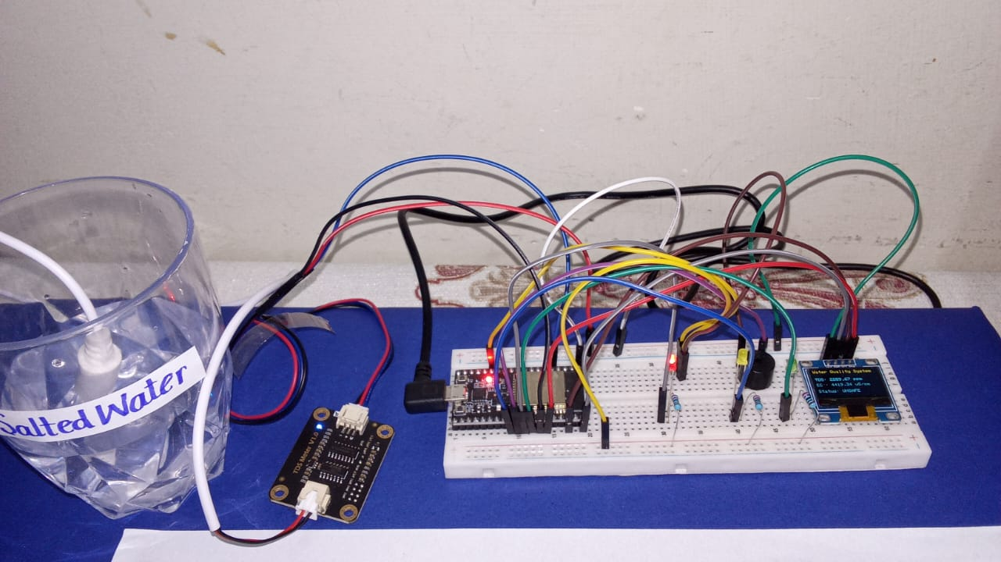

## Blynk cloud Output data:

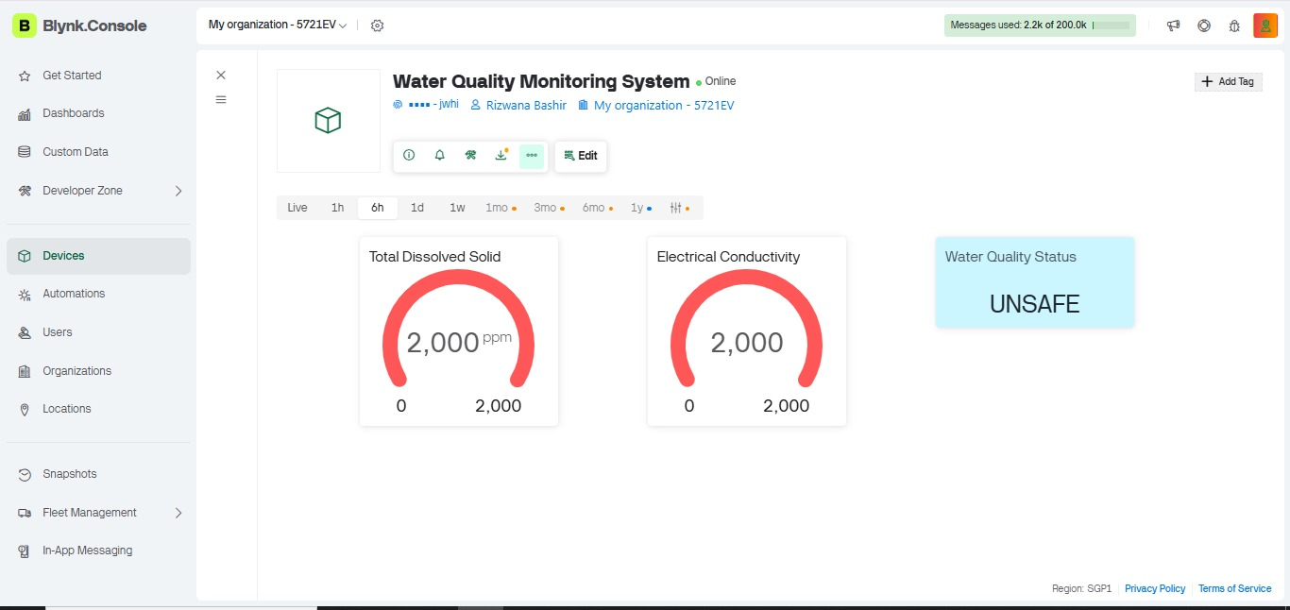

## Results

The system successfully displays real-time TDS and EC values on the OLED screen. Water quality status is clearly indicated using LEDs and text display. The Blynk mobile application shows live sensor readings, allowing users to monitor water quality remotely. The buzzer provides immediate alerts when water quality exceeds safe limits.

## Conclusion

The Water Quality Monitoring System successfully demonstrates an IoT-based approach to real-time water quality monitoring. The system accurately measures Total Dissolved Solids (TDS) and Electrical Conductivity (EC) using an ESP32 microcontroller and a TDS sensor. It provides immediate feedback through visual indicators (green, yellow, and red LEDs), a buzzer alert for unsafe water, and an OLED display. Data is also transmitted to the Blynk Cloud platform for remote monitoring via a mobile application.

Through testing with mineral water, tap water, and salted water, the system reliably classified water into **SAFE**, **MODERATE**, and **UNSAFE** categories. This project highlights the effectiveness of integrating sensors, microcontrollers, and cloud-based platforms for automated, real-time water monitoring. The system is cost-effective, easy to use, and can serve as a practical solution for households, laboratories, and educational demonstrations.

## Future Scope

The Water Quality Monitoring System can be further enhanced and expanded in several ways to improve functionality, accuracy, and applicability:

1. **Integration of Additional Sensors:**
   * Incorporating sensors for pH, dissolved oxygen (DO), turbidity, and temperature can provide a more comprehensive assessment of water quality.
2. **Automated Water Treatment:**
   * The system can be connected to automated purification or filtration units to treat water in real-time whenever unsafe conditions are detected.
3. **Advanced Data Analytics:**
   * Cloud-based analytics can be added to track water quality trends over time, predict contamination, and generate reports for better decision-making.
4. **Mobile & Web Dashboard Enhancements:**
   * Developing a full-featured mobile or web application with notifications, alerts, and historical data visualization for multiple locations.
5. **IoT Network Expansion:**
   * Multiple monitoring stations can be networked together to create a smart water monitoring system for neighborhoods, factories, or municipal water supplies.
6. **Energy Efficiency and Portability:**
   * The system can be redesigned to be solar-powered and portable, allowing continuous monitoring in remote or off-grid areas.
7. **Machine Learning for Prediction:**
   * Future versions could implement machine learning algorithms to predict water contamination and provide early warnings before unsafe levels are reached.